Week 1 Parent Eblast

To: All Parents
Subject Line: Run4Fund$ Kick Off – Week 1
__________________________________________________________________

Hello Sandburg Families!!!
We are excited about our upcoming Run4Fund$ fundraiser and want to share the details with you. This is our 8th annual Run4Fund$ and is our largest fundraiser for the school. Every student participates in the Fun Run, gets a t-shirt and has the chance to earn great individual, class and school-wide prizes and events!

What’s Happening This Week:
9/13 Kick off Assembly: Your Virtual Assembly is on 9/13. Students will participate in an exciting assembly and hear lots of information about the Run4Fund$ and all the prizes they can earn! Your student will bring home a Parent letter with more details about the Run4Fund$. We have attached a Donor Tracker to help you keep track of pledges and donations.

Please help your student(s) to find sponsors and donors right away so they can reach their individual and class prize goals! We have a school web platform so anyone can easily donate! www.r4funds.com/schools/sandburgrun22/donate/

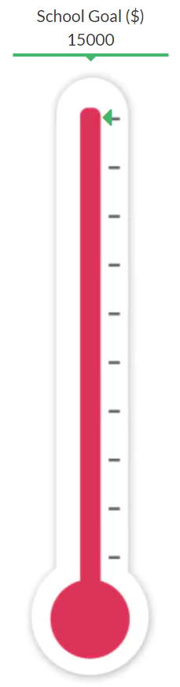
Check with your employer to see if they have a Company Matching program for employee charitable donations. If so, these funds can be used toward your student’s total!

Start sending out informational emails from our website to potential donors!

Goals and Prizes:
Our school goal is $50,000 and we will all enjoy a Dippin Dots Party when we reach it! There are several individual and class prizes that your student can earn as well, we hope that you will help and encourage your students to reach their fundraising goals.
You can check on your student’s donations (use password carl22) and keep track of your class progress on your website - www.r4funds.com/schools/sandburgrun22/

Individual goals/prize:
- $500+ = Gift Card for Inflatable Rental

Class goals/parties are:
- $70 Avg/Student = Glow Party Kit
- $80 Avg/Student = Glow Rings
- $90 Avg/Student = Glow Wands

School Goals/Parties are:
- $20,000 = Waterslide & Obstacle Course on Field Day
- $30,000 = Foam Party
- $40,000 = Hydroblast at Field Day
- $50,000 = Dippin Dots Party

All Dates:
9/13: Run4Fund$ Virtual Assembly
- Your student will participate in an all school kick off assembly at school to learn more about the Run and the prizes they can earn.
- A Parent Letter with a QR code will come home today or in their weekly school folders so students can start contacting friends and family to raise funds towards their prize goals.
- Help your child(ren) by sponsoring them for the Run4Fund$ and helping them find other sponsors like Grandparents, Aunts and Uncles, Neighbors, and family friends.
- Go to www.r4funds.com/schools/sandburgrun22/ to easily send out emails to potential sponsors, make online Donations and check online totals. Password: carl22
- Check out the website for the cool prizes that your child(ren) can earn!

9/20: Run4Fund$ Email Campaign Due Day
- We have a great email tool on your website to help increase students’ donations!
- On the Family Resources page at www.r4funds.com/schools/sandburgrun22/, parents/students can send out donation requests/informational emails to friends and family. When you or your students send out 10 emails through this system by 9/20 at 5pm your student will go into a drawing for a great prize!

9/23: Early Bird Donations Due
- Students can win prizes by getting online Early Bird Donations by 5pm today!
- There are 3 levels of Early Bird Drawings - $35, $150 & $250. Your student will be entered in each level that they achieve.

9/23: Run4Fund$ Date
- Your child(ren) will run/walk as many laps as they can around the 1/16 mile track in their 30 minute run slot. Students average 25-30 laps with a 50 lap max.

9/30: All Donations Due
- All donations are due today. We are asking that donations be done online via our website to avoid unnecessary contact or money handling. We will still accept cash/checks that students should turn in to the office.

10/26: Prize Day
- Parents are welcome! Check with your teacher to see what time your student is participating in the Prize Events.

School Fun Run Website:
Our website has lots of information and tools to help you and your student make the most of our fundraiser. Be sure to check it out at www.r4funds.com/schools/sandburgrun22/! Some quick highlights are:
- Simple online giving for friends, family and other donors! We are asking for all donations to be made online. If you still send a check or cash, it must be turned in to the office by your student by 9/30. Please make checks out to: Sandburg PTO.
- Students or parents can send out emails to potential donors directly through the website! Personalize the pre-loaded email message on the “Family Resources” tab to let everyone know how to sponsor your student! No need to go door to door asking for donations.
- Parents can check students’ donations easily on the “Check my student donations” tab
  - You will use the password carl22 and then follow directions on the following page to see posted donations for your student(s)
  - If donations are not showing up, it is most likely because the student name entered on the donation does not match the student name on the school roster. Run4Fund$ staff will go through each donation to make sure they match up to a student as they run reports – no donations are lost or uncounted.
- Goal tracking thermometers in real time for school and classrooms!
- Answers to lots more questions in our FAQ’s section!
- Important dates, prizes and other reminders all in one place!

Any questions? Please contact us at: sandburgpto@gmail.com

To see a run and some of the great prizes, check out our video (please note that this video was filmed pre-covid so many changes have been made to keep everyone safe): Parent Welcome Video

